Alter the table by adding the column salary & Alter the table by modifying the column **name**

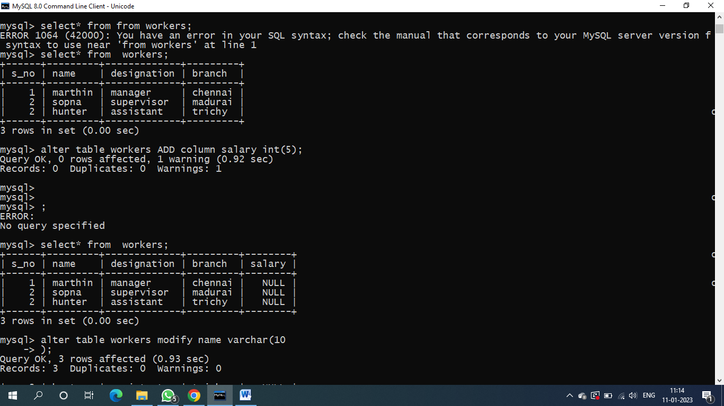

Describe the table **workers**

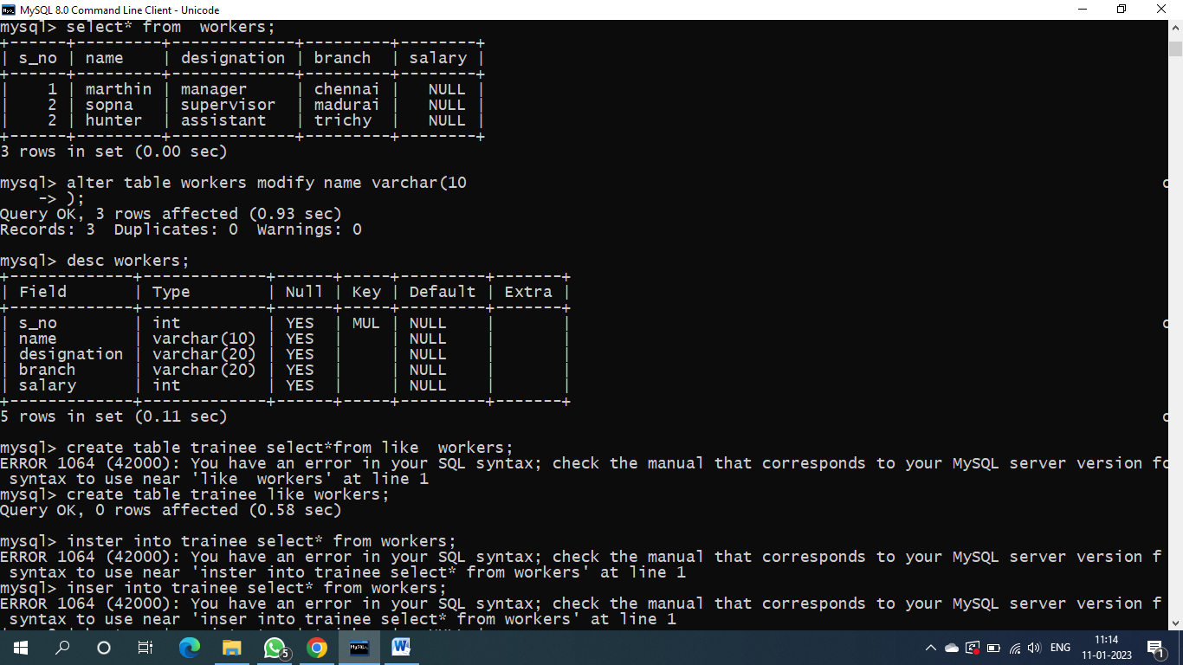

Copy the table workers as trainee

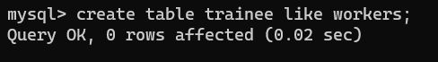

Delete the second row from the table



Drop the table

